When you should perform the admin portal steps: ?
- User reports the Sync error after completing (posting time confirmation) the work order operation in SAM. Operation status is set to “Completed” but SAP S/4 HANA status is still in REL.
- User see “TRANSFER” only option on the mobile device.

To Resolve above issues, perform below steps
1.Execute Tcode: /SYCLO/ADMIN
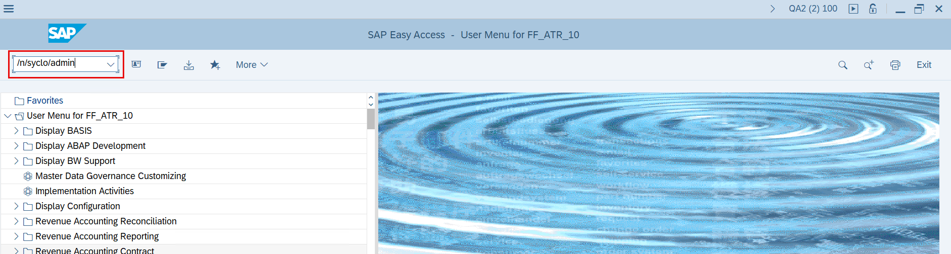
2.Click on “Administration” on system administration and monitoring portal
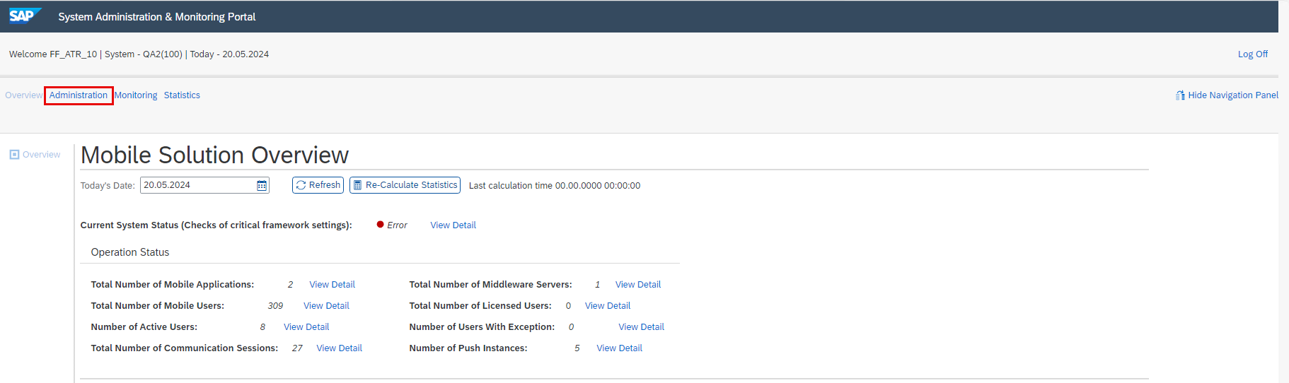
3.Click on “User Management”
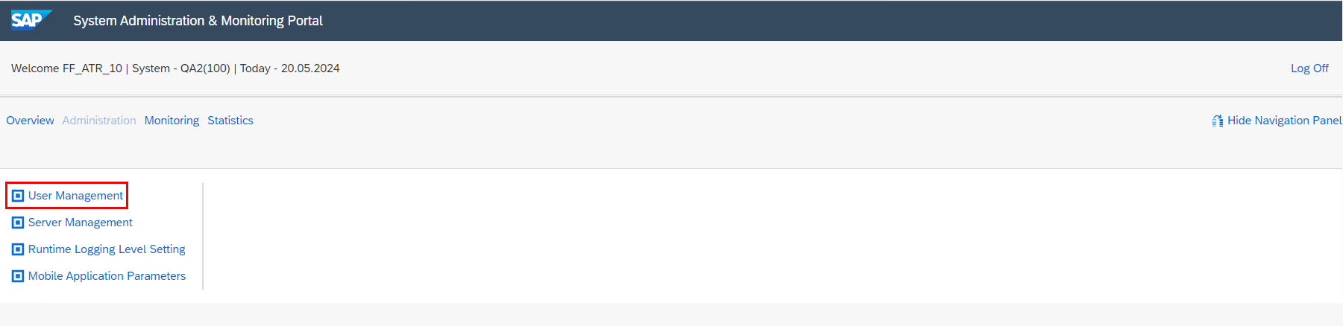

4.Select Mobile application as “SAP service and asset manager 2210”
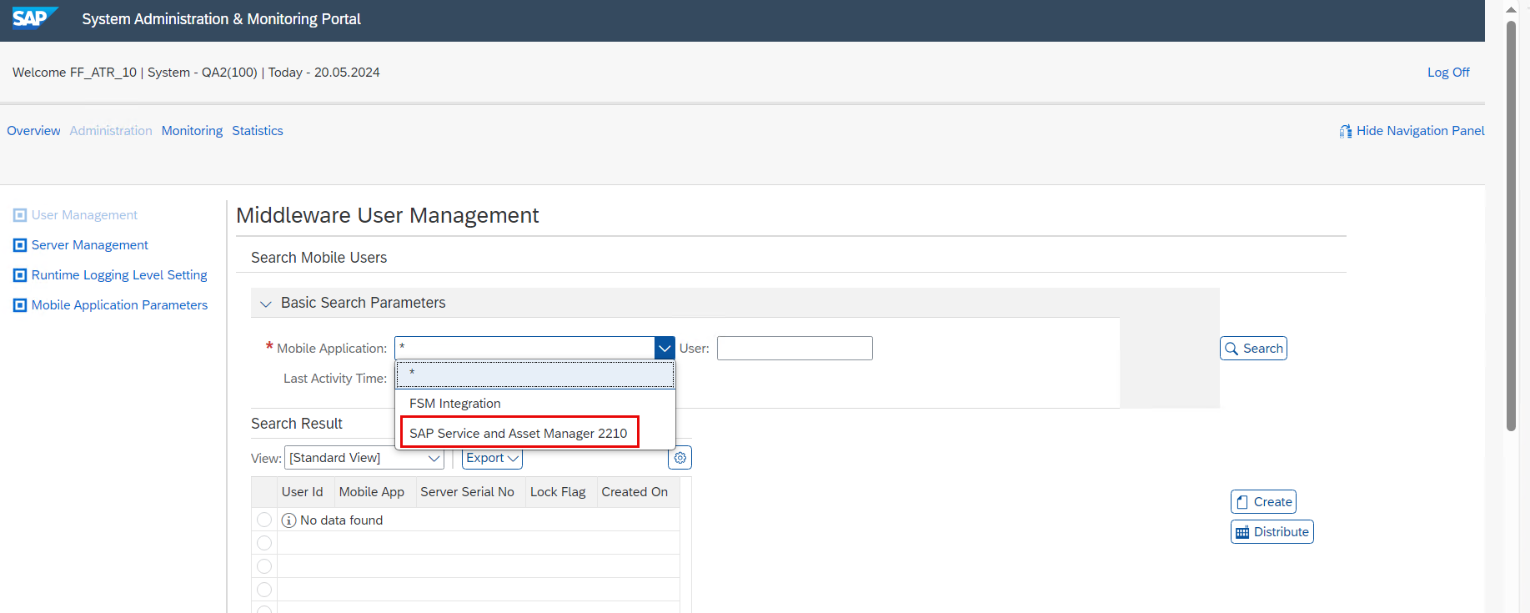
5.Select applicable user and click on “search”
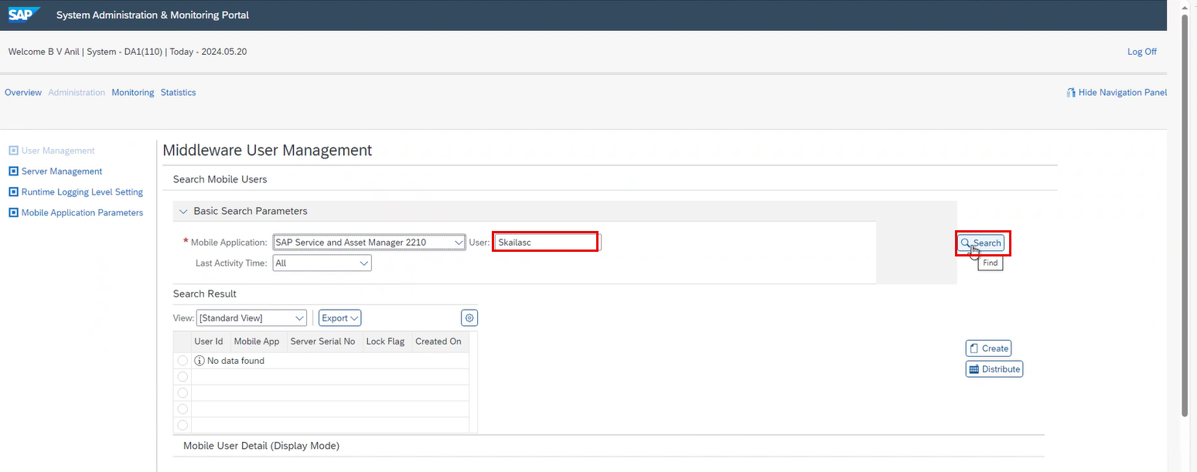

6.Select the user and click on “Preference info” tab
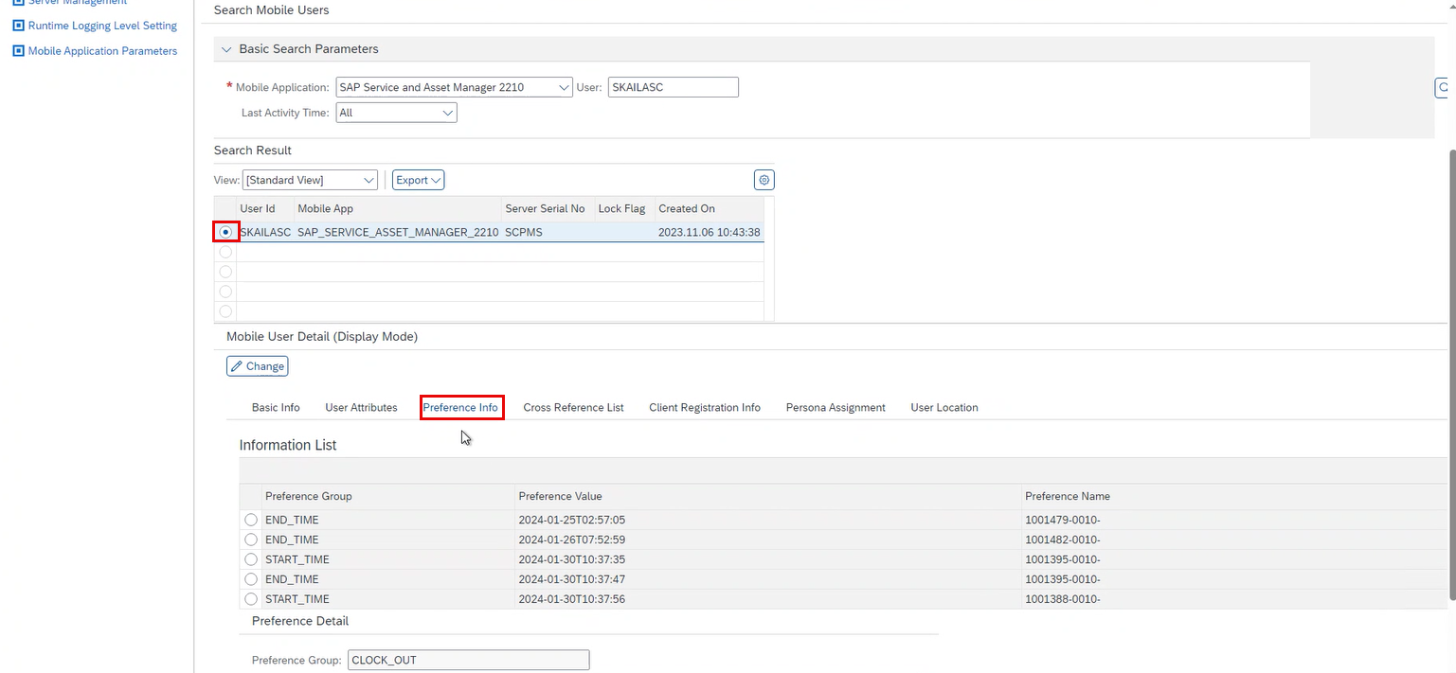
7.Search for preference value as “STARTED” and click in “Change”
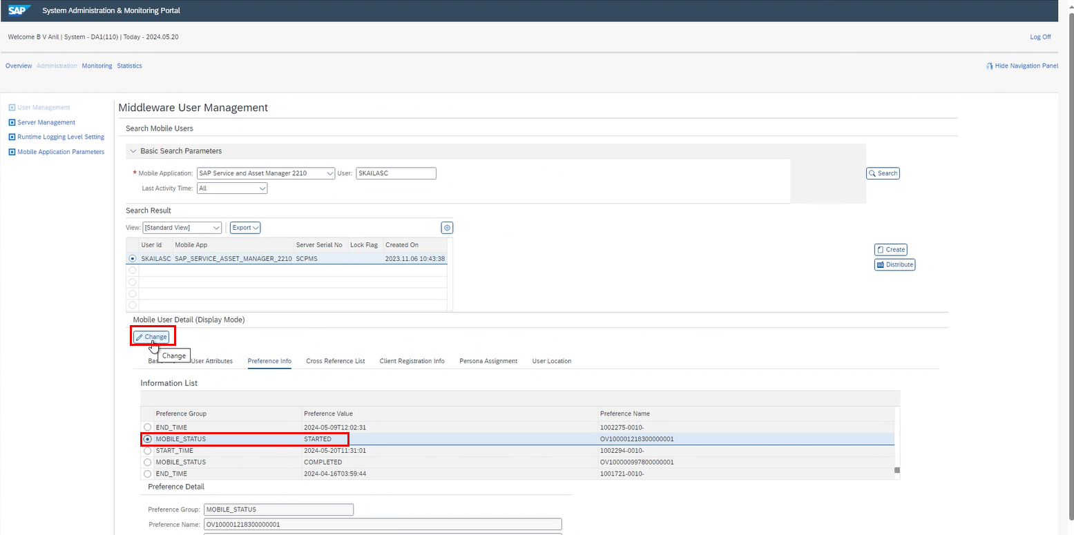

8.Delete the selected preference value and click on “Save”
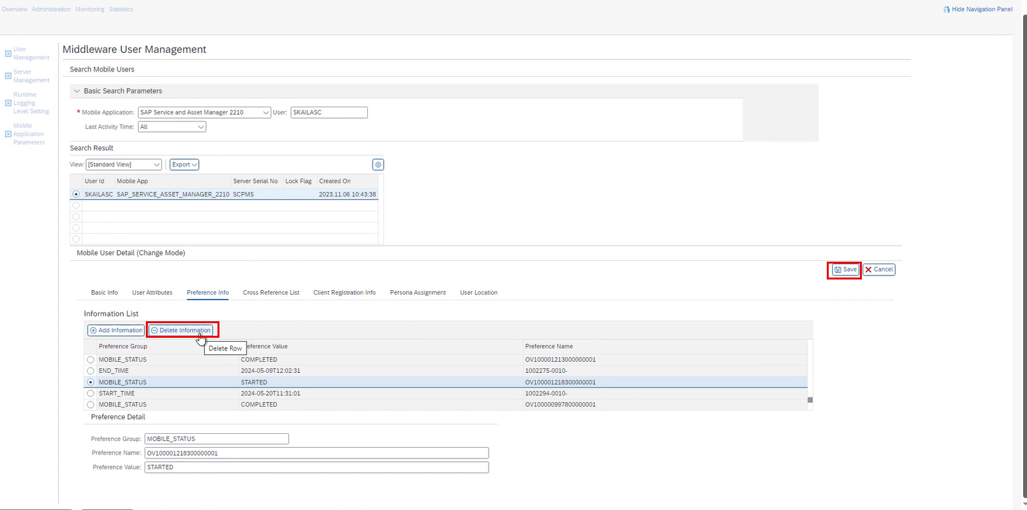
9.Preference value gets deleted successfully.
